Willow Bay Beauty $323,500
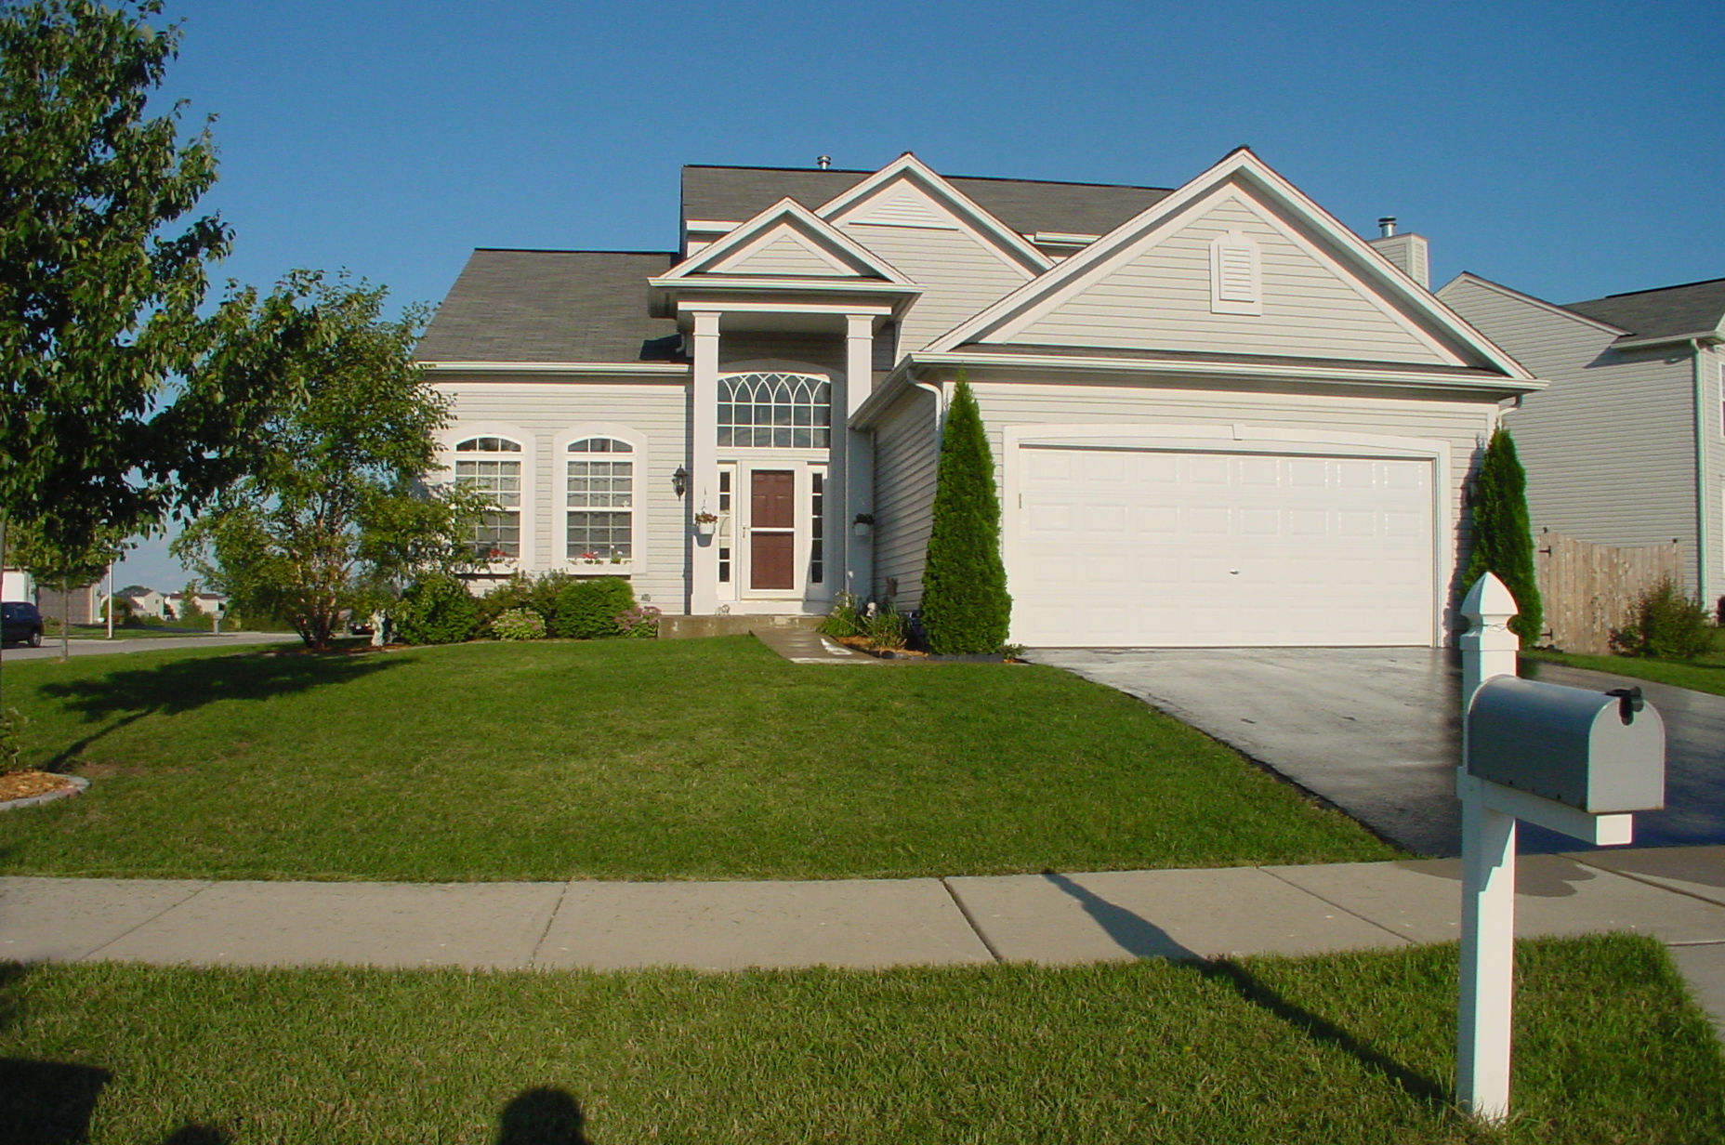
Features and Facts
Rare 3 bedroom Carrington model, 9’ First floor ceilings.
Oversized Private Corner cul-de-sac lot, 12000+ square feet
See fireworks from your custom brick patio. Views of Wetlands and wildlife
3 bedrooms, 2.5 Baths
Large Two-story foyer
Volume Living room ceiling
Vaulted Master bedroom Ceiling with ceiling fan
Huge Family Room with ceiling fan
Optional Expanded Kitchen with island, pantry, planning desk, new counters, Franke sink, faucet and lighting
42” Maple Cabinets in rich cherry stain, sink tip out tray
Custom cedar fence, Dog Run
2.5 car garage with door opener and keypad entry
2.5 Car Garage, with Service door, EDO and shelving
All appliances including Whirlpool washer, dryer and refrigerator
Oversized 1st Floor Laundry Room, New Maple Cabinets
Energy efficient Furnace & Water Heater
Central Air Conditioning
Large master bedroom suite
HUGE Master bath features New 2-person Jacuzzi, custom tile, 10’ vanity, shower
New carpet entire first floor
New Cherry laminate flooring in upstairs hallway
Large walk-in closet in master suite
Updated Lighting throughout
Partial basement with crawlspace
Room Sizes
Living room - 12’0” x 13’6”
Family room - 14’3” x 18’6”
Dining room - 10’ x 11’4”
Kitchen - 16’6” x 13’6”
Master bedroom – 13’ x 17’
Bedroom 2 – 10’ x 10’
Bedroom 3- 10’ x 12’7”
Total = 2000 sq. feet
Schools
U-46 Schools
Costs
Asking price: $323,500
Property taxes: $6940
One Owner Non-smoking home built in 2000
Pride of ownership evident throughout
1073 Compass Point
Elgin, Illinois 60123
Call Sherry - (630) 945-7070
Visit the website: http://www.1073compasspoint.com/HomeSite

Additional Photos
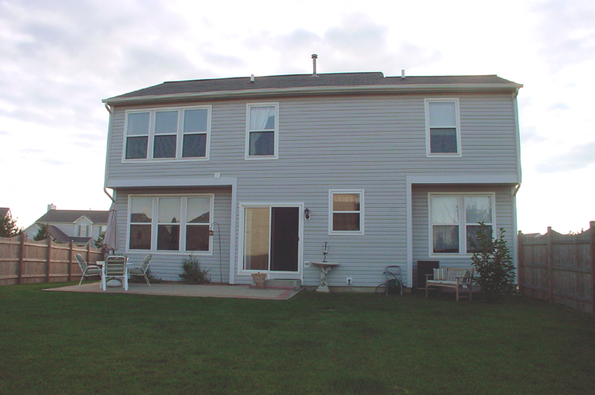 | 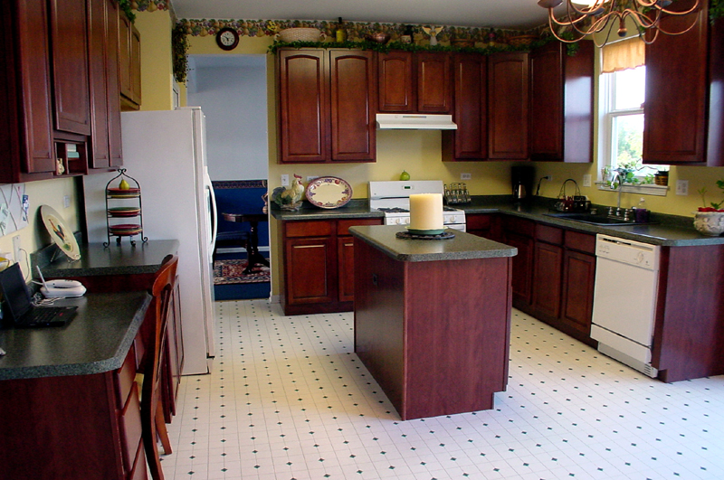
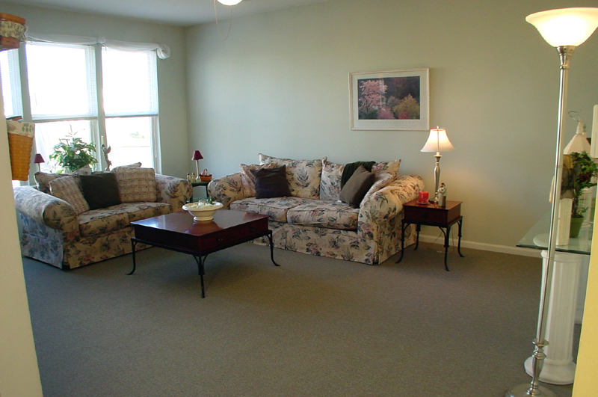 | 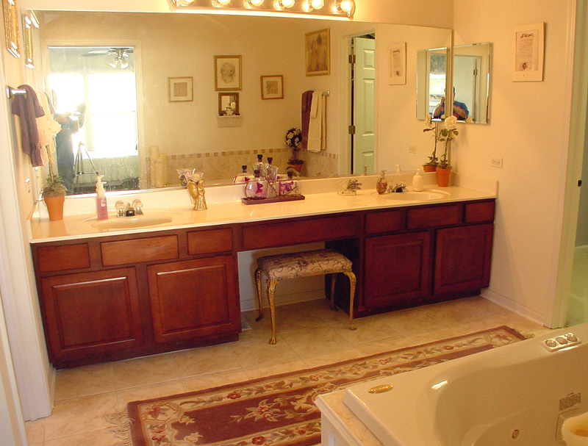
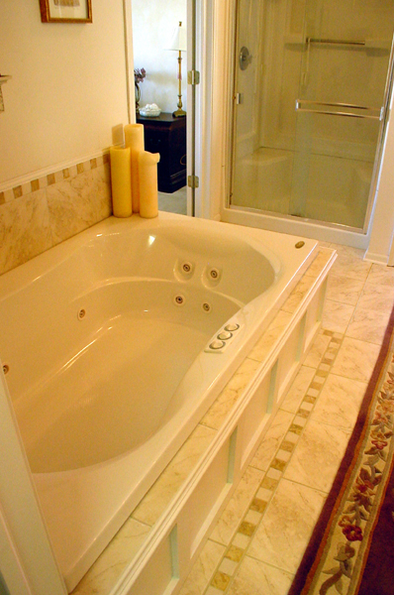 | 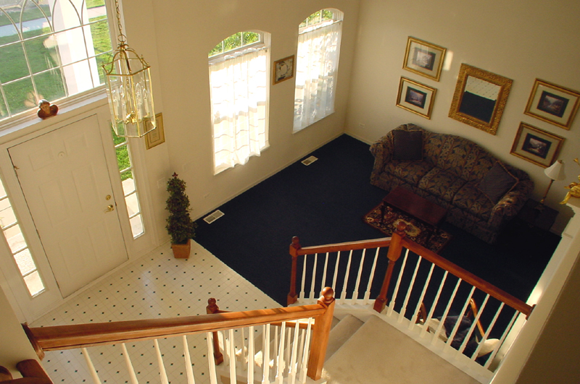

Floor plan – 1st Floor


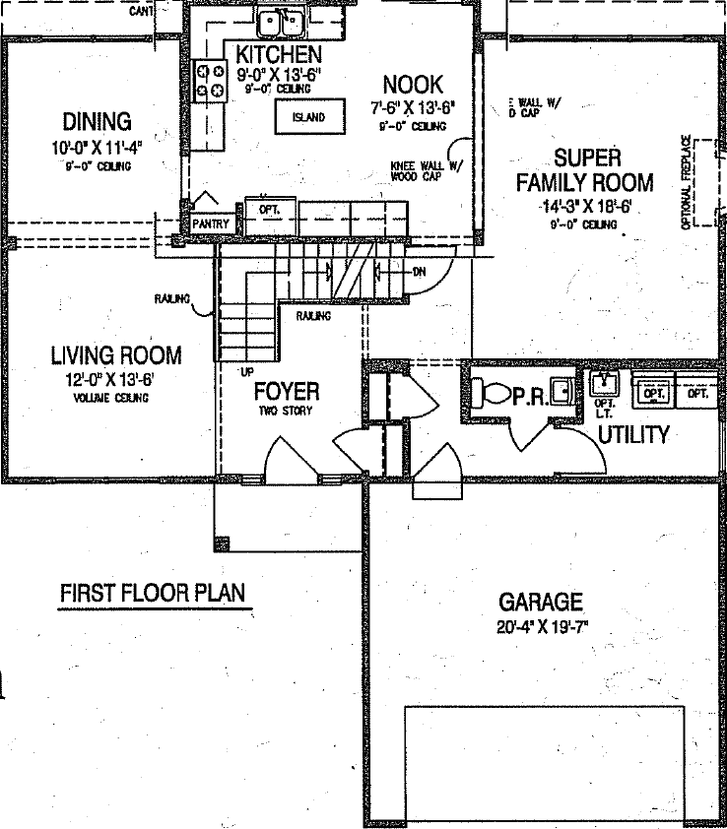

Floor plan – 2nd Floor

